**Experiment–2**

**StudentName:Arpit Rana Branch: BE-CSE**

**Semester:6th**

**SubjectName:APLab-2**

**UID:22BCS10776**

**Section/Group: NTPP - 603/A DateofPerformance:11/01/24 Subject Code: 22CSP-351**

**Problem-1**

1. **Aim:**TwoSum
2. **Objective:**

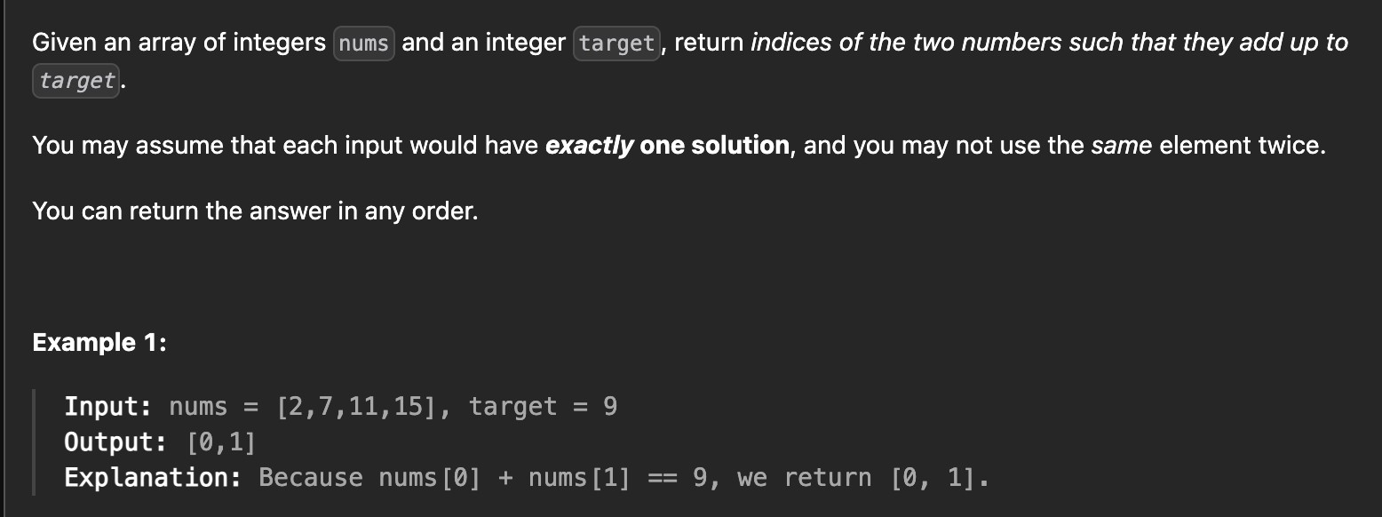

1. **Implementation&Output:**

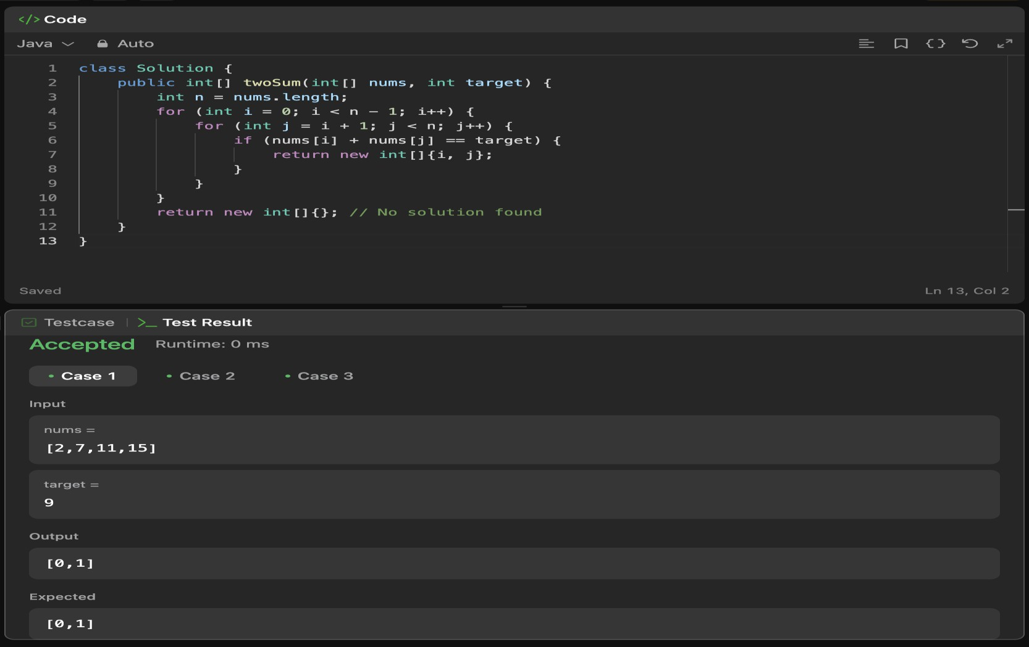

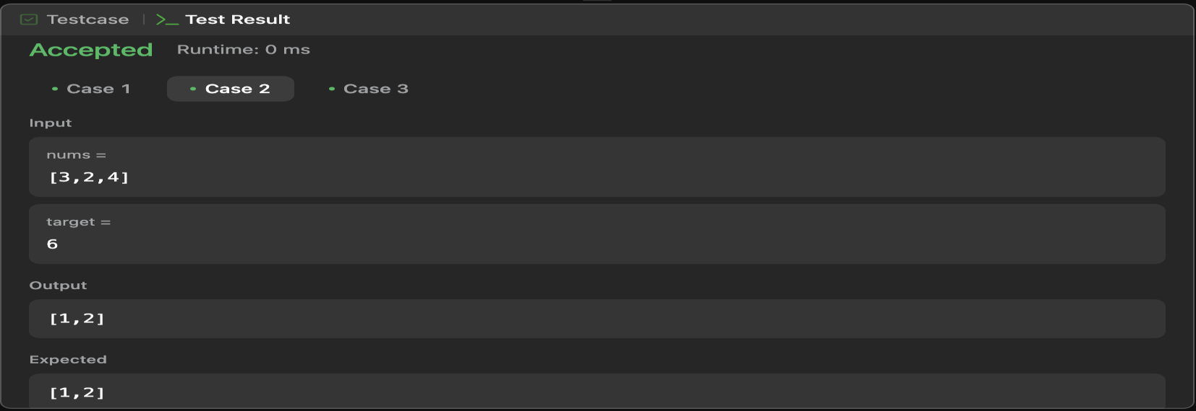

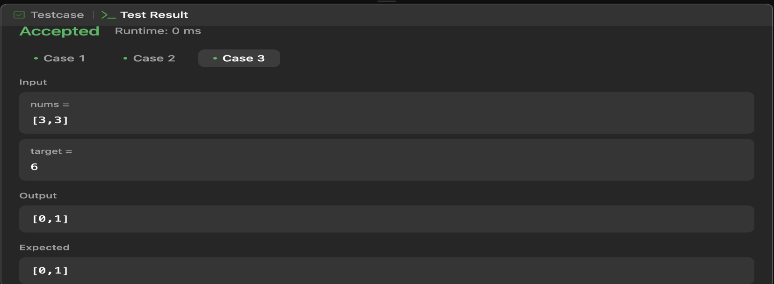

1. **LearningOutcomes:**
   * **NestedLoops:**Demonstrateshowto iteratethroughallpairsofelements inan array using nested loops.
   * **BruteForceApproach:**Solvestheproblemusingabrute force methodwithO(n²) time complexity, highlighting its inefficiency for large inputs.
   * **ArrayIndexing:**Teacheshowtoaccessandcompareelementsinanarraybytheir indices.
   * **EdgeCaseHandling:** Handlescaseswherenosolutionis foundbyreturningan empty array

**Problem-2**

1. **Aim:JumpGame**
2. **Objective:**

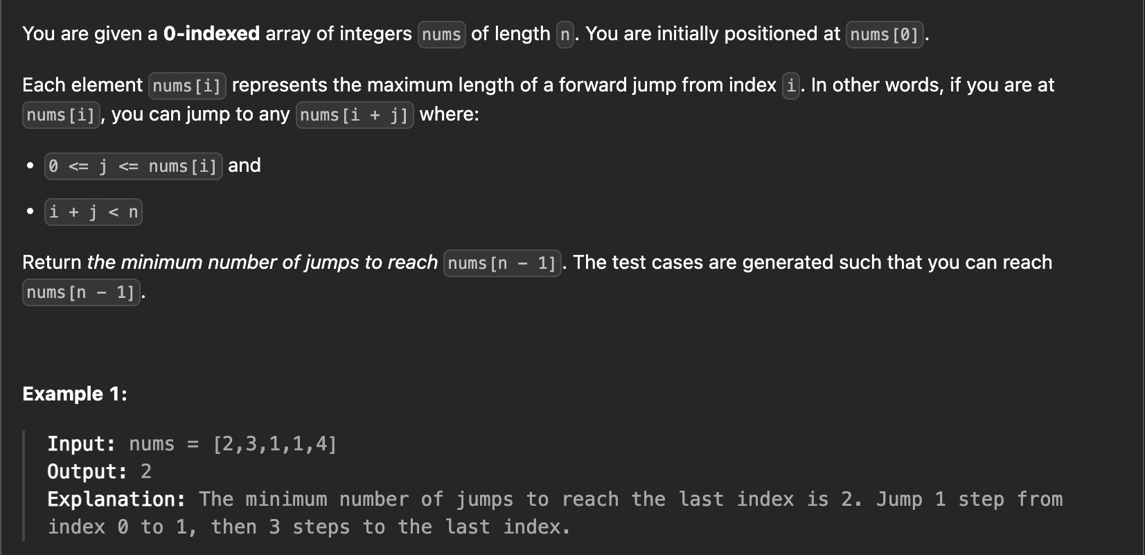

1. **Implementation&Output:**

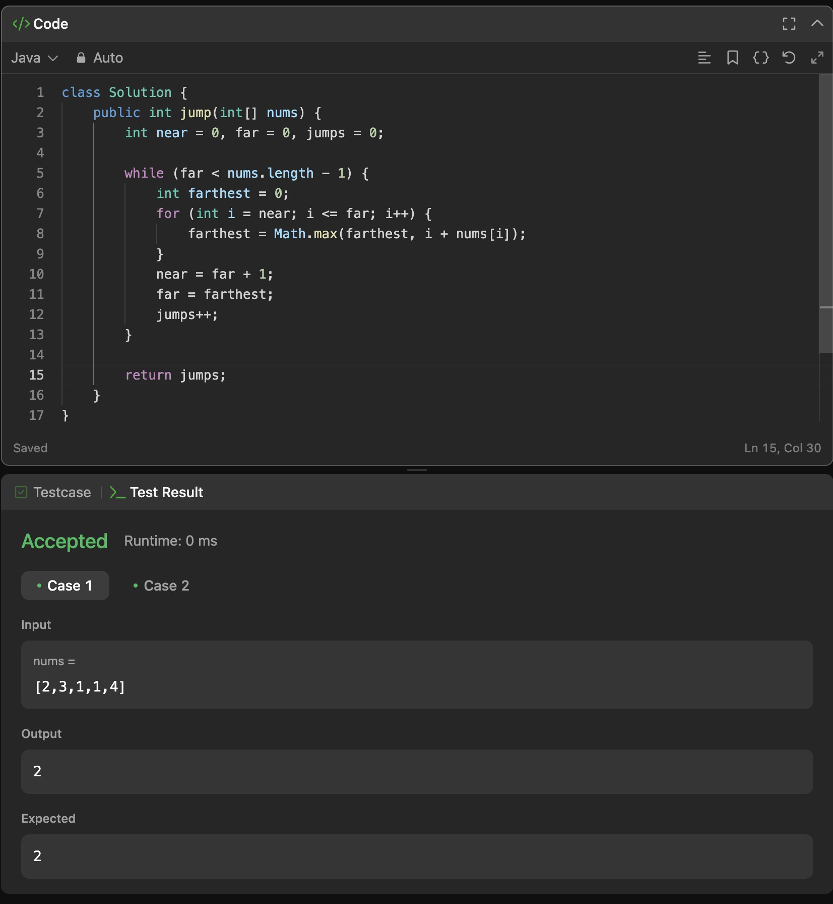

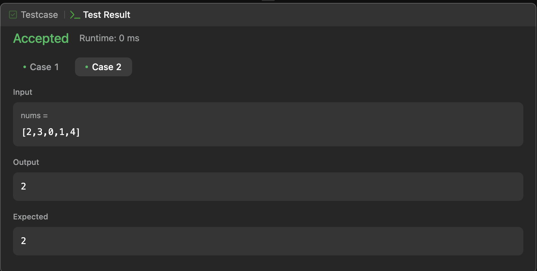

1. **LearningOutcomes:**
   * **GreedyStrategy:** Learnhowtoapplyagreedyapproachtosolveoptimization problems by always choosing the farthest reachable index to minimize jumps.
   * **TwoPointerTechnique:**Understandhow tousetwopointers(nearandfar)to track the current jump range and expand it iteratively.
   * **EfficientJumpCalculation:** Learntocalculatethe minimumnumberofjumps required to reach the end of an array while traversing the input only once.
   * **TimeComplexityAwareness:**Recognize thatthealgorithmoperatesinO(n)time complexity, optimizing performance over brute force methods.